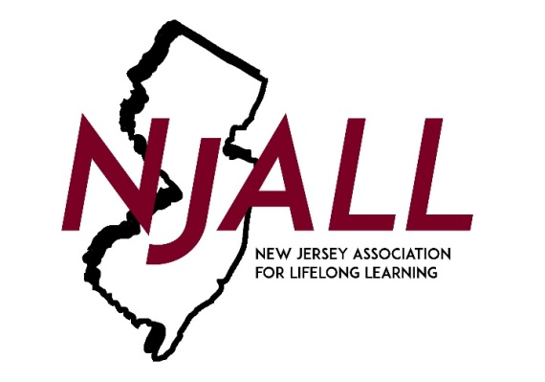

NJALL AWARDS NOMINATION FORM 2022

Award Category (check one)

___ Barry Semple Lifelong Learning Leadership Award
___ Teacher of the Year Award

Nominee (Person or Organization) _______________________
(If organization, list contact person) _______________________
Position/Role _______________________
Organization/Institute _______________________
Address _______________________
Daytime Phone ( ) _______________________

Person(s) submitting this nomination

Name _______________________
Address _______________________
_______________________
Daytime phone contact ( ) _______________________
Email: _______________________

Only one application per nominee is necessary but letters of support will also be read by the committee. Please attach information about the candidate you are nominating, specifically addressing how the individual or organization meets the following criteria:

- Why do you believe that your candidate should receive this award?

- Using specific examples, describe the outstanding contributions this individual or organization has made to students, teachers, staff and/or the adult education community, particularly as they relate to leadership.

- Please provide examples of the qualities that have made this person or organization so effective within the adult education community.

PLEASE EMAIL ALL INFORMATION BY February 28, 2022 to connieschwein@gmail.com.com
Please use the subject: NJALL Awards Nomination 2022

