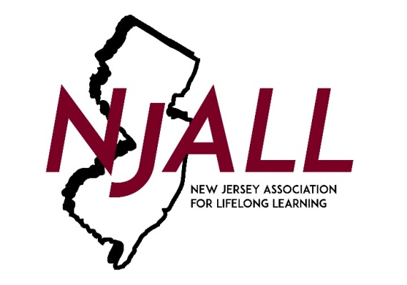

NJALL AWARDS NOMINATION FORM

Award Category (check one)

___ Barry Semple Lifelong Learning Leadership Award
___ Teacher of the Year Award

Nominee (Person or Organization) _______________________
(If organization, list contact person) _______________________
Position/Role _______________________
Organization/Institute _______________________
Address _______________________
Daytime Phone ( ) _______________________

Person(s) submitting this nomination

Name _______________________
Address _______________________
_______________________
Daytime phone contact ( ) _______________________
Email: _______________________

Only one application per nominee will be reviewed. Please attach information about the candidate you are nominating, specifically addressing how the individual or organization meets the following criteria:

- Why do you believe that your candidate should receive this award?

- Using specific examples, describe the outstanding contributions this individual or organization has made to students, teachers, staff and/or the adult education community, particularly as they relate to leadership.

- Please provide examples of the qualities that have made this person or organization so effective within the adult education community.

PLEASE EMAIL ALL INFORMATION BY January 31, 2021 to connieschwein@gmail.com.com
Please use the subject: NJALL Awards Nomination 2021

